*Use Case Diagram*

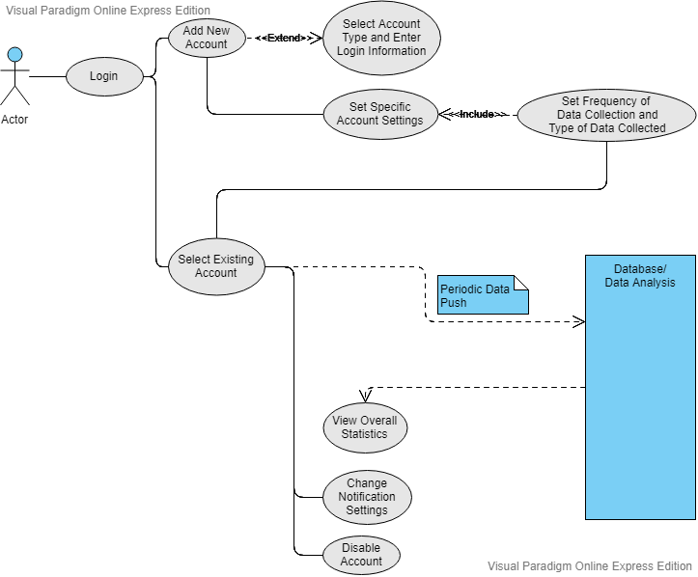

*User Stories*

* As a parent, I want to monitor my child’s social media so that I can detect their moods and any dangerous behavior/thoughts.
* As a parent of a child with known cases of depression, I want to ensure that my child is not exposed to social media posts that trigger depression-related feelings so that I can minimize harmful influences from the internet.
* As a stressed college student who is struggling with courses, I want to know how my social media activity may be implicitly affecting my mood and mental health so that I can avoid distractions from social media.